**Nama : Ari Rocadi**

**NIM : 20220801339**

**Mata Kuliah : Machine Learning**

**Tugas Pertemuan 4**

1. Jawaban

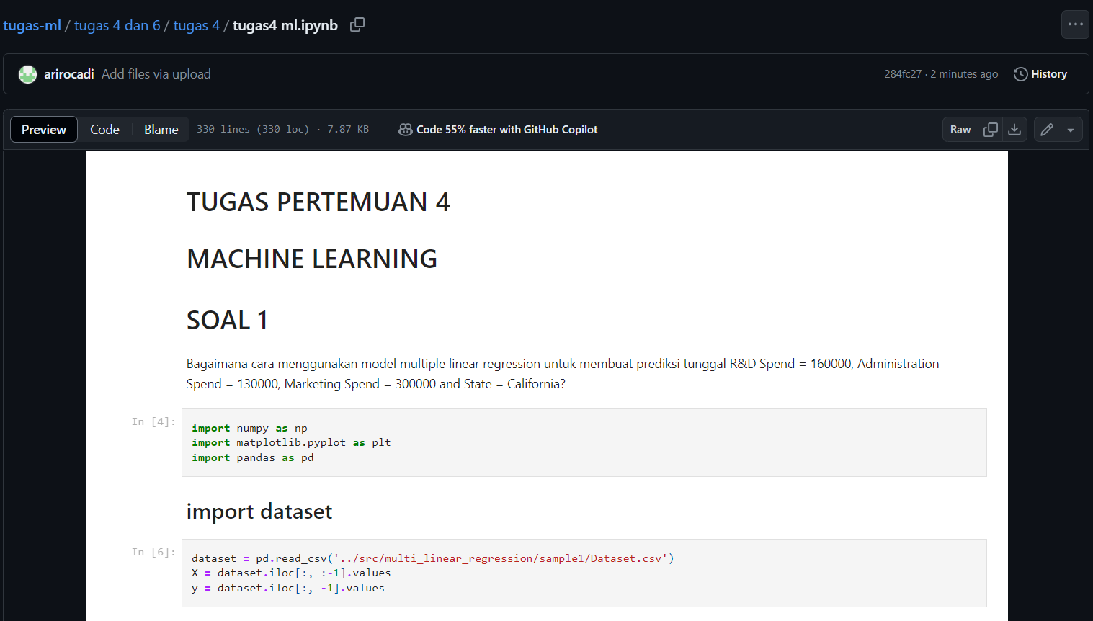

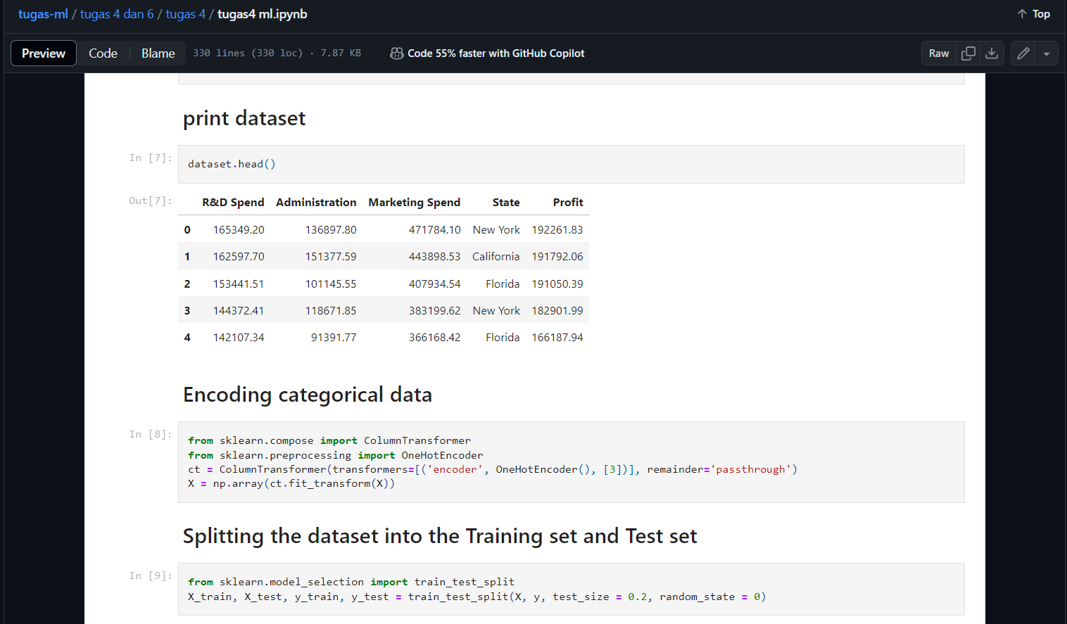

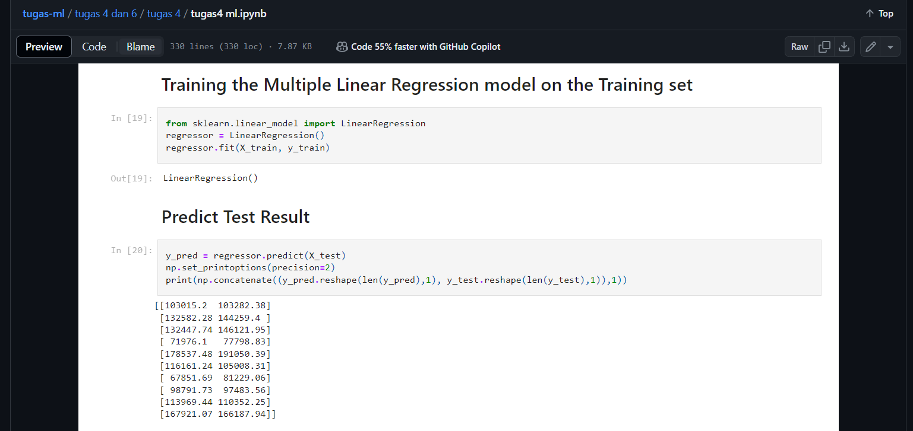

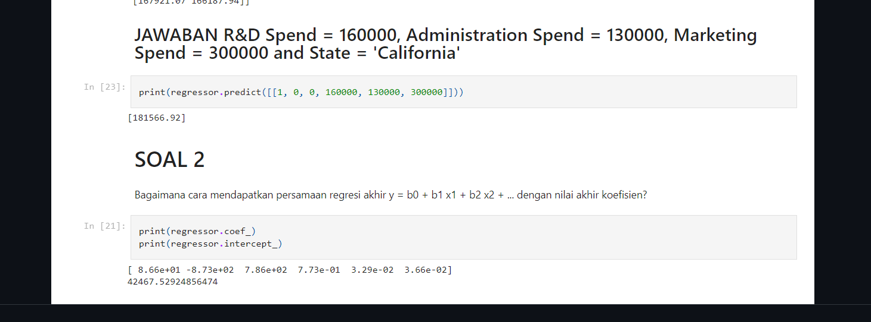

1. Jawaban



Link Github

<https://github.com/arirocadi/tugas-ml/blob/main/tugas%202%20ml.ipynb>